4.AIM:-To implement UML diagrams for STOCK MAINTAINANCE SYSTEM…

1.STATECHART DIAGRAM:-

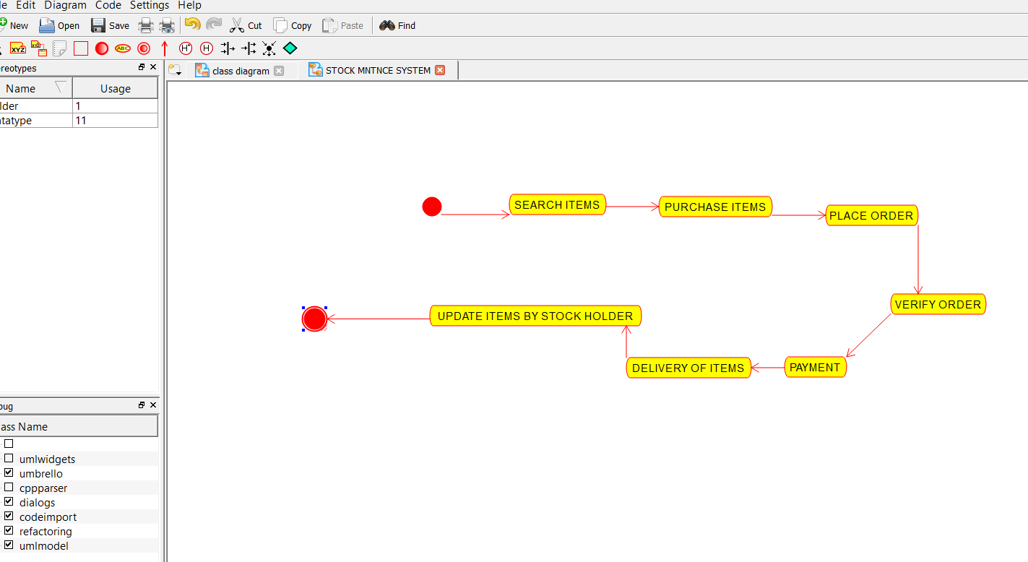

2.DEPLOYMENT DIAGRAM:-

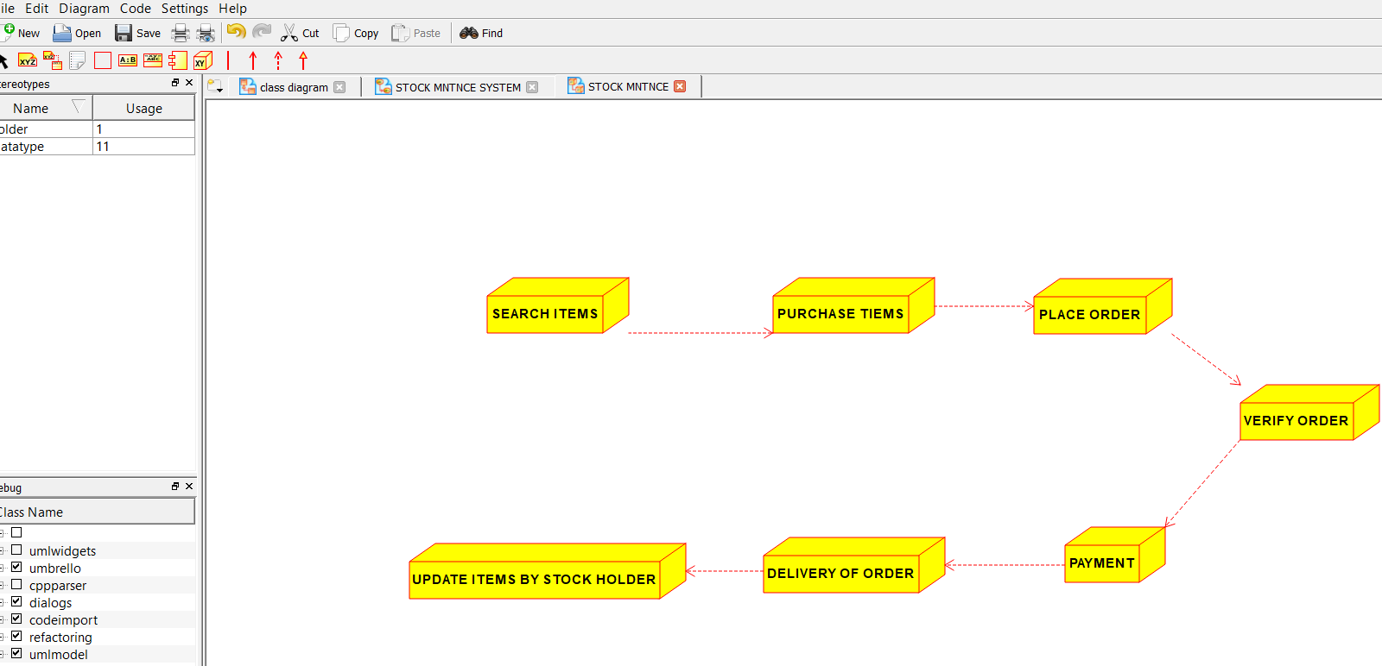

3.PACKAGE DIAGRAM:-

